**Capital Improvement Sales Tax Fund**

|  |  |
| --- | --- |
| **Project Name:**  **Riverwalk Park & Trail** | **Department:**  **Parks & Recreation** |
| **Type of Project:**  **Improvement and Rehabilitation** | **Contact:**  **Chuck Soules** |
| **Estimated Project Cost:**  **$850,000** | |

**Description:**

The Riverwalk Park & Trail will strengthen the overall trail network for runners, bikers, walkers, and wheelers. Riverwalk supports the community identity through active, prominent trail networks. This project will promote recreation and exercise opportunities close to home and within neighborhoods. This will expand the transportation system beyond street networks, enhancing active transportation options. The Riverwalk Park intends to create a linked system of parks, trails, and natural areas.

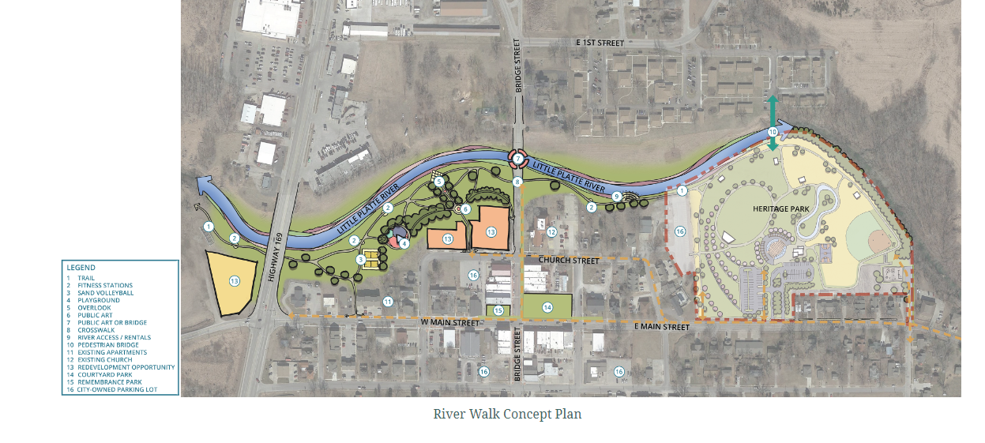

**Justification:**

The Riverwalk Park & Trail was identified as part of the Parks & Recreation Master Plan. In 2022, the City of Smithville applied for a MARC Grant and was successfully awarded the grant for the construction of the Riverwalk Park Phase I.

The Riverwalk Park & Trail represents a great opportunity for Smithville, local businesses, and the economy. This will encourage people to lengthen their visits in the downtown area. As customers extend their time downtown, the opportunities for businesses to generate additional revenue increases. In addition, the Riverwalk will connect multiple existing trails and allow residents and visitors to travel using different modes of transportation other than riding their cars.

**Impact on Operating Costs**

This project will have an impact on operations costs. It is expected that the number of visitors will increase therefore additional Park Maintenance staffing will be necessary. This is to ensure the area and the fields remain in well-kept and clean condition.

**Estimated Expenditures**

|  |  |  |  |
| --- | --- | --- | --- |
|  | **FY2026** | **FY2027** | **Total** |
| **Engineering** | **$50,000** | **-** | **$50,000** |
| **Construction** | **$400,000** | **$400,000** | **$800,000** |
| **Total** | **$650,000** | **$400,000** | **$850,000** |

**Funding Sources**

|  |  |  |  |
| --- | --- | --- | --- |
|  | **FY2026** | **FY2027** | **Total** |
| **Parks & Stormwater Sales Tax** | **$50,000** | **-** | **$50,000** |
| **Capital Improvement Sales Tax** | **$400,000** | **$400,000** | **$800,000** |
| **MARC Grant Reimbursement** | **($240,000)** | **($240,000)** | **($480,000)** |
| **Total Net Cost** | **$210,000** | **$160,000** | **$370,000** |